|  |  |
| --- | --- |
|  |  |

**Faculty of Technology and Engineering**

**Chandubhai S Patel Institute of Technology**

**Department of Computer Science & Engineering**

**PRACTICAL – 4**

Roll no.:23CS046 Date:    /    /

|  |  |  |  |  |  |
| --- | --- | --- | --- | --- | --- |
| Academic Year | : | 2024-25 | Semester | : | 4 |
| Course code | : | CSE207 | Course name | : | Design and Analysis of Algorithms |

**AIM:**  **3**

|  |  |
| --- | --- |
| 3.1 | You are managing a logistics company that delivers parcels across various cities. The parcels are stored in a large warehouse in an unsorted array, where each element represents the weight of a parcel in kilograms. To optimize the delivery routes, you need to sort the parcels by weight before loading them onto trucks.  Your task is to implement Divide and Conquer algorithms to sort the parcel weights. Compare implemented Sorting algorithm’s time complexity analysis: worst case, average case and best case. |

**3.1.1 (a) Data Table: Merge Sort Algorithm**

|  |  |  |  |
| --- | --- | --- | --- |
| **Input Size** | **Best Case** | **Average Case** | **Worst Case** |
| **5** | 19 | 23 | 27 |
| **10** | 47 | 53 | 59 |
| **15** | 79 | 87 | 95 |
| **20** | 115 | 125 | 135 |
| **Practical Complexity** | O(n logn) | | |

**3.1.1 (b) Line Chart: Merge Sort Algorithm**

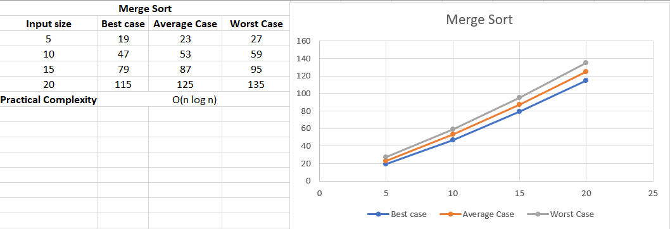

**3.1.2 (a) Data Table: Quick Sort Algorithm**

|  |  |  |  |
| --- | --- | --- | --- |
| **Input Size** | **Best Case** | **Average Case** | **Worst Case** |
| **5** | 12 | 17 | 24 |
| **10** | 30 | 39 | 58 |
| **15** | 52 | 65 | 98 |
| **20** | 80 | 97 | 148 |
| **Practical Complexity** | O(n logn) | | O(n^2) |

**3.1.2 (b) Line Chart: Quick Sort Algorithm**

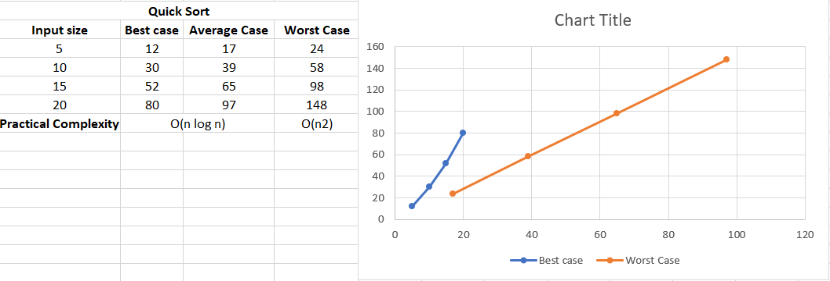

|  |  |
| --- | --- |
|  |  |

**Faculty of Technology and Engineering**

**Chandubhai S Patel Institute of Technology**

**Department of Computer Science & Engineering**

**Performa for PRACTICAL – 4**

Roll no.: Date:    /    /

|  |  |  |  |  |  |
| --- | --- | --- | --- | --- | --- |
| Academic Year | : | 2024-25 | Semester | : | 4 |
| Course code | : | CSE207 | Course name | : | Design and Analysis of Algorithms |

**AIM:**  **3**

|  |  |
| --- | --- |
| 3.1 | You are managing a logistics company that delivers parcels across various cities. The parcels are stored in a large warehouse in an unsorted array, where each element represents the weight of a parcel in kilograms. To optimize the delivery routes, you need to sort the parcels by weight before loading them onto trucks.  Your task is to implement Divide and Conquer algorithms to sort the parcel weights. Compare implemented Sorting algorithm’s time complexity analysis: worst case, average case and best case. |

**Answer the Following Questions:**

1. What are the key advantages of using a Divide and Conquer approach in algorithm

design compared to traditional iterative approach?

2. Compare performance of Merge Sort and Quick Sort Algorithms in terms of time complexity and space complexity.

3. How selection of pivot elements affects the performance of Quick sort algorithm?

**Conclusion:**

**Grade / Marks Sign of Lab Teacher with Date**